User Manual

Introduction:

The system is intended to be a team management system for my local Football club. It is designed to manage the Players, Matches and Goal scorers. The user is able to add, remove, update and view the data that has been previously entered into the system. The user will also be able to lay out a team sheet for any upcoming matches.

Prerequisites:

The program has been compiled into an .exe file, so no software prerequisites are required.

Operating System:

The program was developed on a 64 bit Windows 7 machine; therefore the program will only be executable on a 64 bit machine.

Tutorial:

Using the main menu:

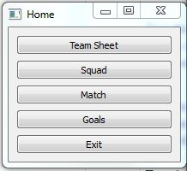

Buttons

Each of the Labels is a push button that links to the relevant screen. To get to the screen you wish to see, press the labelled button.